**User Manual**

**SERIS**

Solar Energy Research Institute Singapore



Cloud Based Realtime Analytical Monitoring of Photovoltaic Systems and Weather Parameters Project

|  |  |
| --- | --- |
| Project Name | SERIS |
| Team Name | SE25PT7 |
| Document Version | Draft |
| Document Writer | Nay Lin Aung |
| Document Reviewer | PT7 members |
| Reference Documents | SE25PT7SERIS\SERIS\TECH\USER\UG\WORK IN PROGRESS/SERIS_UM.docx |
| Last Modified | 18-Jan-2019 |
| Approved By | Kaung Myat Bo |
| Approved On | 26-Jan-2019 |

|  |  |
| --- | --- |
| © 2018 ISS. The information contained in this document is the property of ISS. The contents must not be reproduced, wholly or in part, for purposes other than for which it has been supplied, without the prior permission of ISS, or, if it has been furnished under contract to another party, as expressly authorized under that contract. ISS shall not be liable for any errors or omissions. |  |

**Version History**

|  |  |  |  |
| --- | --- | --- | --- |
| Version | Author/Reviewer |  | Brief description of changes |
| Draft | Nay Lin Aung | 18/01/ 2019 | Initial Version. |
|  |  |  |  |
|  |  |  |  |
|  |  |  |  |
|  |  |  |  |

**Table of Contents**

**Version History** 2

1. Overview 4

2. Login 4

3. New User Registration 5

4. Forgot Password 6

5. Station Management 7

6. User and Station Mapping 8

7. System Administration 9

8. Data Download 10

9. Real-time Dashboard 11

10. Health Check 12

11. Report 13

12. Alerts and Notifications 14

13. Auditing and Tracebility 15

## Overview

The Solar Energy Research Institute of Singapore (SERIS) conducts research, development testing and consulting on solar energy technologies and their integration into power systems and buildings. SERIS is globally active but focuses on technologies and services for tropical regions, in particular for Singapore and South-East Asia.

The aim of the project is to develop a cloud-based platform for integrating and managing real-time Analytical Monitoring of PV systems performance - from small rooftop systems to large ground- based PV power plants in the multi-MW range across different climate zones. Collected data will be used for extensive research programmes on yield projections, which are of vital importance to project developers as well as investors and degradation studies of PV modules & systems.

## Login

Open the browser, and by entering URL of SERIS page, login page will be shown. Keying in registered email and password will lead to login into the SERIS system and it will display dashboard.

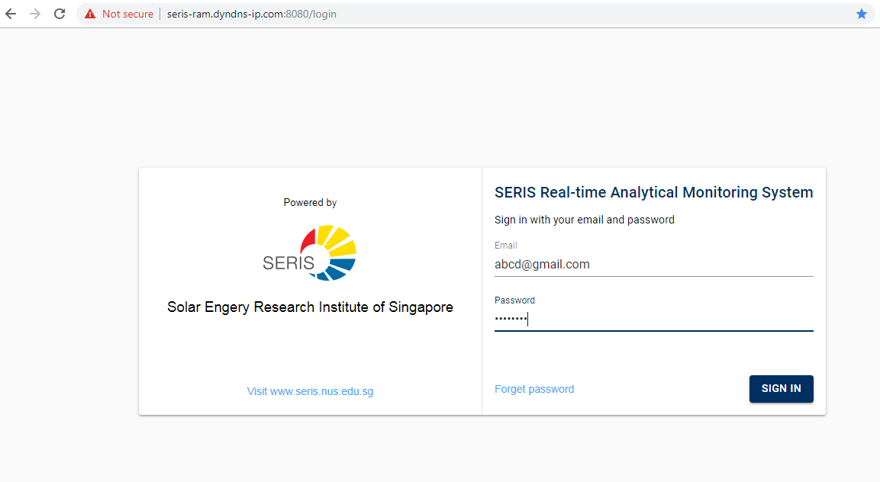

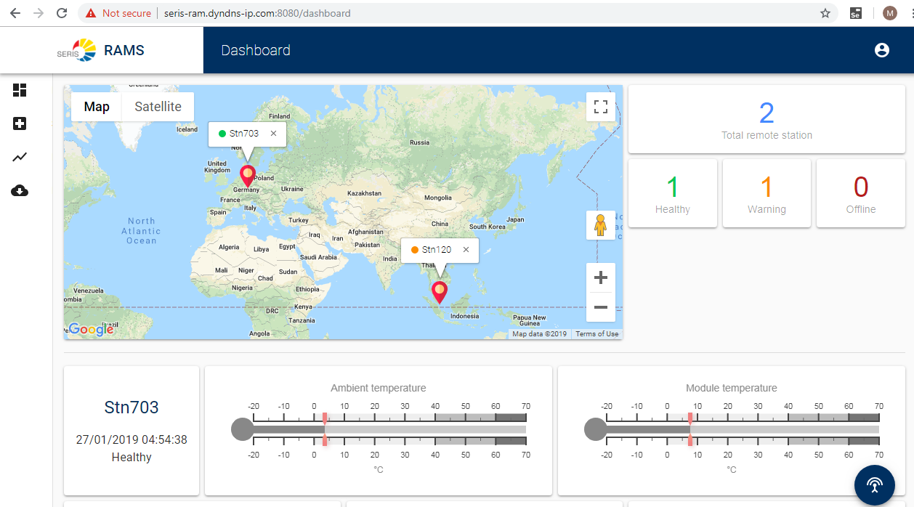

## New User Registration

To create a new user, the system should be logged in with administrater right.

System user without administrater right can not create/delete user.

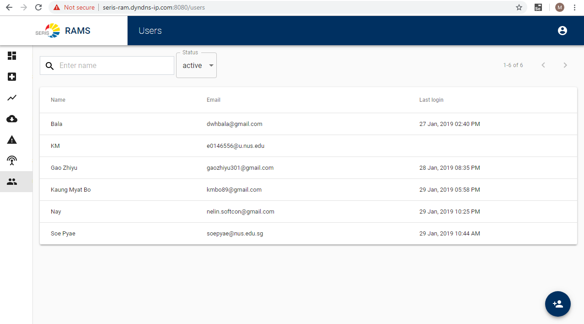

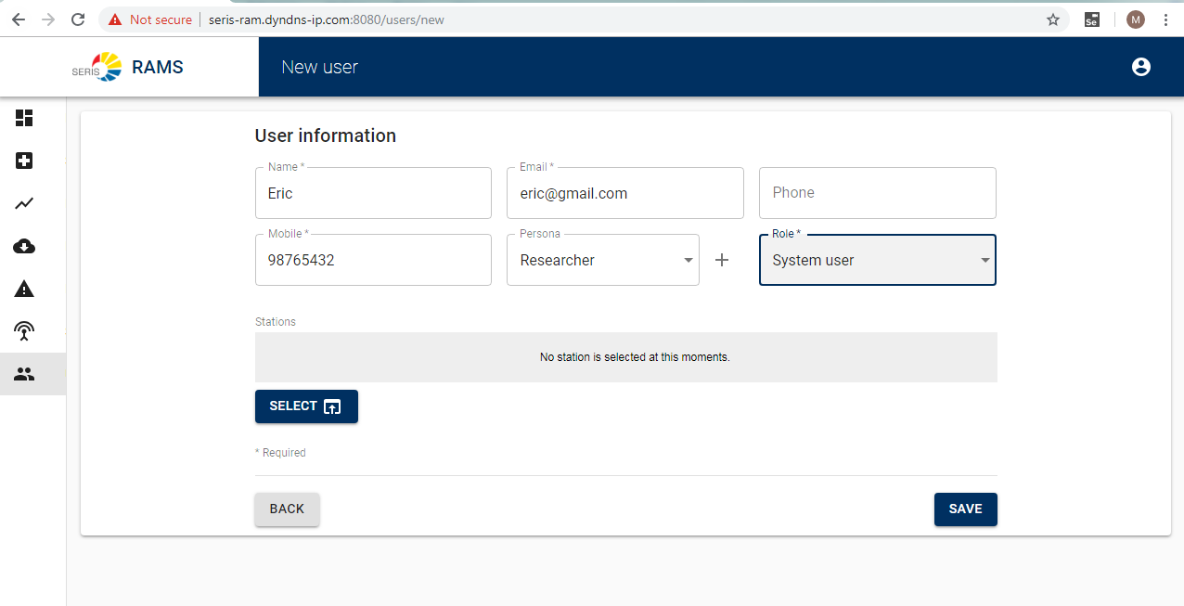

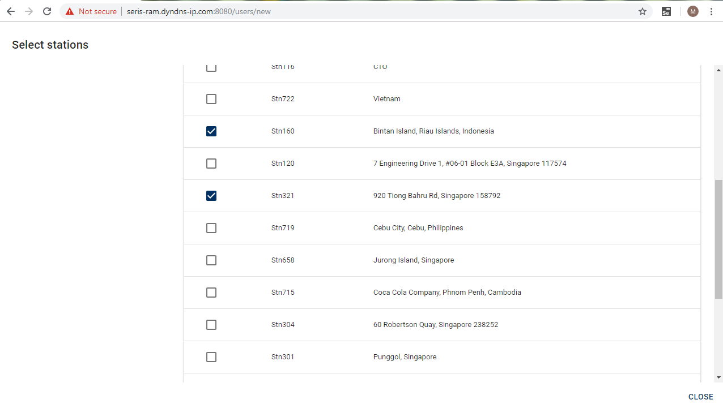

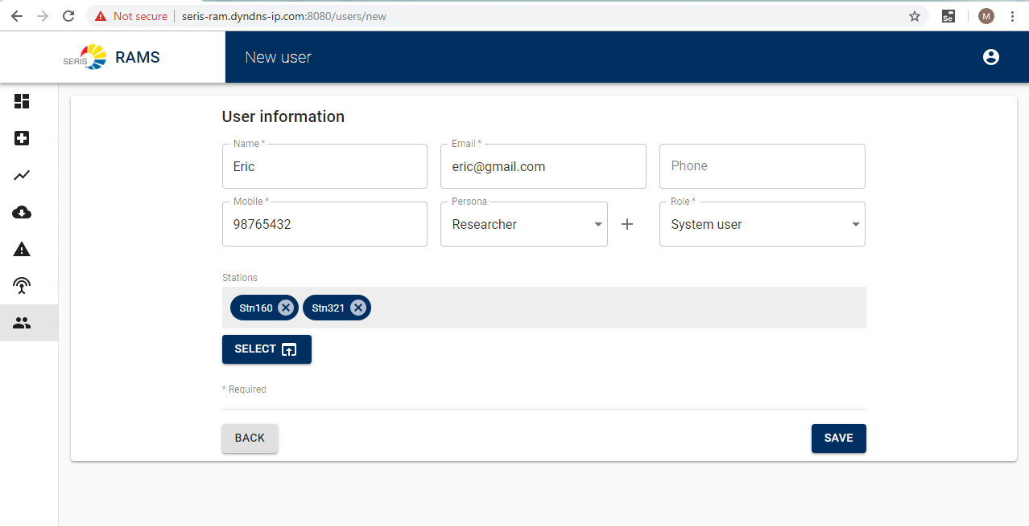

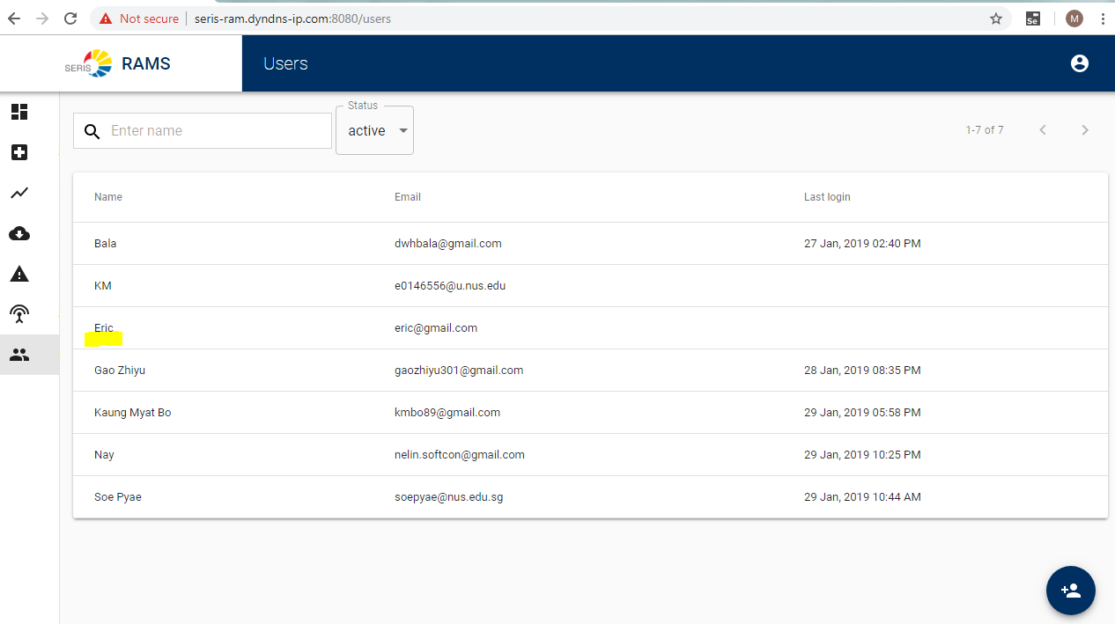

## Forgot Password

This option allows an existing user to reset password, in case he/she is not able recollect the current password. A registered user can request for a password reset link to be sent to his/her registered email address. Using this link, the user will be able to choose and

assign a new password.

The System allows the user with appropriate permission to browse list of all stations existing in the system.

## Station Management

A station is a site that has a set of IoT devices tagged to them. The station needs to be registered before it can send data to the system. The System should allow the Users to create, edit, and delete stations to which the IoT devices are tagged to within the RAM application. The lowest level of granularity of devices/sensors has been revised to **stations**, instead of individual devices/sensors.

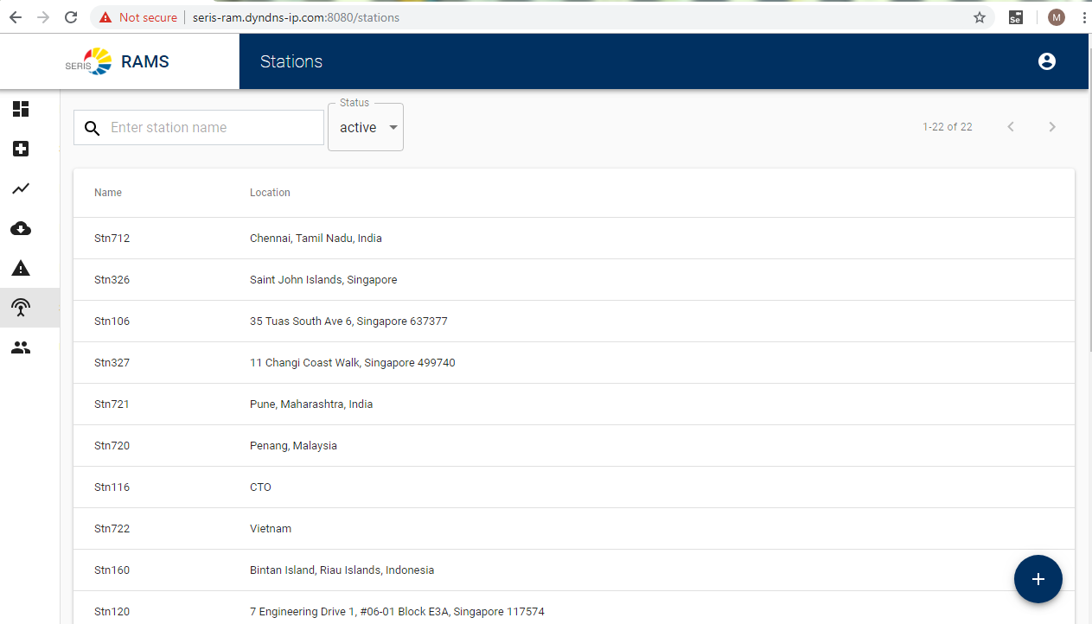

## User and Station Mapping

The System should allow the administrators to create, edit and remove stations mapped to individual users.

## System Administration

Perform setup, configuration and other supervisory / administrative functions to be carried out by the administrators, primarily focused on system / infrastructure level components. The user should be provided with 2 sets of technical documents catering to the system administration functionalities. They are ‘System Setup’ and ‘System Configuration Management’ documents.

## Data Download

The System should facilitate an easy way to download the data from the cloud into their local PC. The user should be able to select a specific station tagged to that user.

The user should be able to customize the download further by specifying a specific month for the data download. The downloaded data will be in the form of csv file to facilitate further data analysis by the users with commonly available tools (for an example excel).

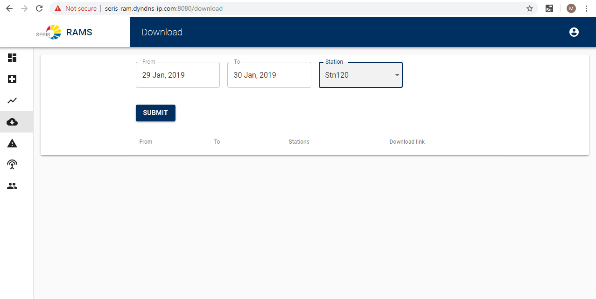

## Real-time Dashboard

There should be option for users to easily access the dashboard. Ideally there the dashboard is to be divided into 3 sections, the ‘**map’**, ‘**health’** and ‘**sensor’**.

The ‘**map’** section displays the station(s) attached to the user on a map. The user should be able to interactively navigate through the map that is presented. The user should be able to select a specific station on the map by a simple click of the mouse.

The ‘**health’** section displays a summary of health status of the stations attached to the user in real-time. Since the health data is sent to the RAM application on a per-minute basis, the health summary is to be refreshed with the same frequency of the incoming health data.

The ‘**sensor’** section displays the data sent from sensors attached to the station in real-time. This section should work in-sync with the ‘map’ section. The ‘sensor’ section displays the selected station’s sensor data. Since the sensor data is sent to the RAM application on a per-second basis, this section is expected to be refreshed on a per-second basis.

## Health Check

## 

## Report

The data should be available and accessible by users in the form of reports, charts, and graphs. The users are able to customize these reports further.

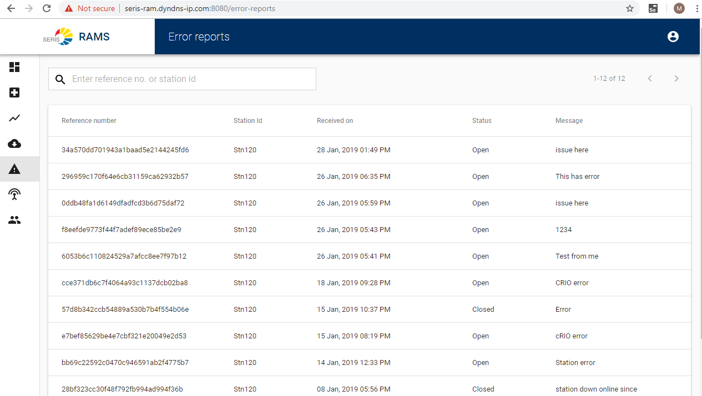

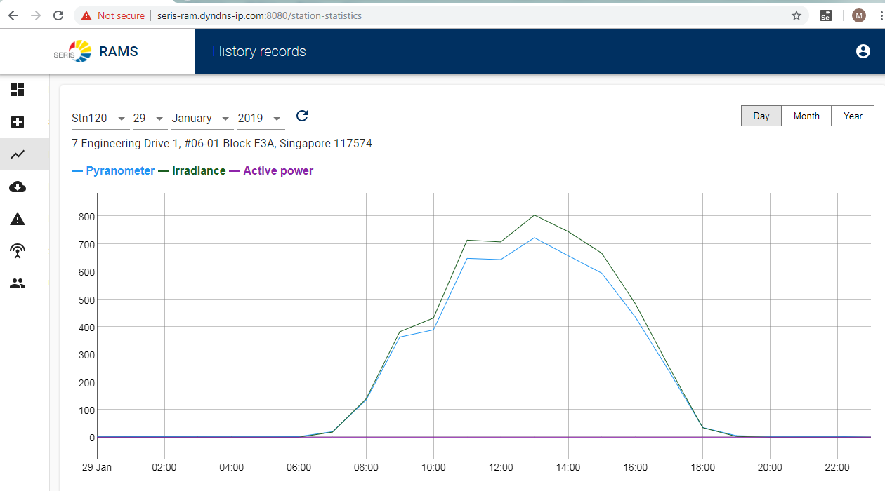

## Alerts and Notifications

The RAM application will record certain important or time-sensitive information, especially around station health status.

In case of station failures, the users have requested it to be recorded for their tracking and closure. The application will receive station failure information in real-time from an external station monitoring application managed by SERIS. The RAM application in-turn will record this information in the notification table, to bring such stationfailures to user’s attention.

The station health code sent by the station indicates the health status and error code. Ideally we should be receiving a ‘1’ meaning station in good health and there are no errors. In case the value is not ‘1’ then this needs to be captured and recorded in the notification table. This will help SERIS to intervene and take corrective action in a timely manner.

## Auditing and Tracebility

The RAM Application is expected to capture and record certain key events and activities performed with in the system.

These include :

* User Login/Logout details (Session details)
* User Management details, specifically creation and deletion of user accounts
* Station Management details, specifically creation and deletion of stations

The audit data captured should be made available and accessible to SERIS administrators. They should be accessible interactively or through a download option for auditing the RAM application’s critical functionalities.